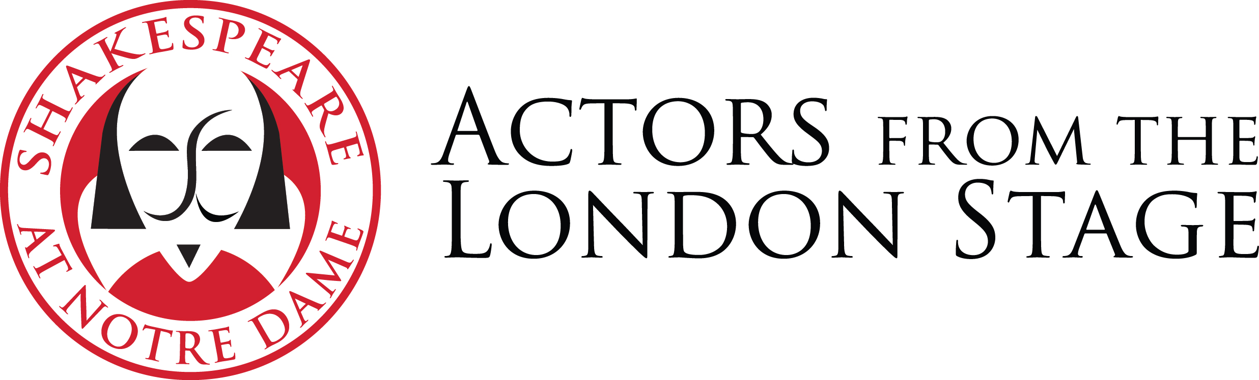
Fall 2019 Tour: Twelfth Night Synopsis

Orsino, the Duke of lllyria, is in love with his neighbor, the Countess Olivia. She has sworn to stay at home for seven years while she mourns the death of her brother and so rejects Orsino’s suit. Nearby, a group of sailors arrive on shore with a young woman, Viola, who has survived a shipwreck in a storm at sea. Viola mourns the loss of her twin brother Sebastian and decides to disguise herself as a boy, and to get work as a page to Duke Orsino.

Despite his rejection, Orsino sends his new page Cesario (Viola in disguise) to woo Olivia on his behalf. Viola goes unwillingly as she has already fallen in love with the Duke. Olivia is attracted by the ‘boy’ and she sends her pompous steward, Malvolio, after him with a ring.

Olivia’s servant, Maria, her fool, Feste, her uncle, Sir Toby Belch, and Sir Toby’s friend, Sir Andrew Aguecheek – whose own affections for Olivia are being exploited by Sir Toby in an effort to fleece him of his money - all conspire to destroy Malvolio’s reputation by playing on his infatuation with Olivia. By means of a false letter they trick him into thinking his mistress Olivia loves him. Malvolio appears in yellow stockings and cross-garters, smiling as they have told him to in the letter. Unaware of the trick, Olivia is horrified and has Malvolio shut up in the dark as a madman.

Meanwhile, Sebastian, who has also survived the shipwreck, comes to Illyria. His sea-captain friend, Antonio, is a wanted man for piracy against Orsino. The resemblance between Cesario and Sebastian leads the jealous Sir Andrew to mistakenly challenge Cesario to a duel. Antonio intervenes to defend Cesario whom he thinks is his friend Sebastian, and is arrested. Olivia has in the meantime met and become betrothed to Sebastian, thinking him to be Cesario.

Cesario is accused of deserting both Antonio and Olivia when the real Sebastian arrives to apologize for fighting Sir Toby. Seeing both twins together, all is revealed to Olivia and to Orsino. Orsino’s fool, Feste, brings a letter from Malvolio and on his release the conspirators confess to having written the false letter. Malvolio departs promising revenge. Maria and Sir Toby have married in celebration of the success of their device against the steward. The play ends in a declaration of marriage between the Duke and Viola, as Feste’s final song returns us to reality.

-- Peter Holland

