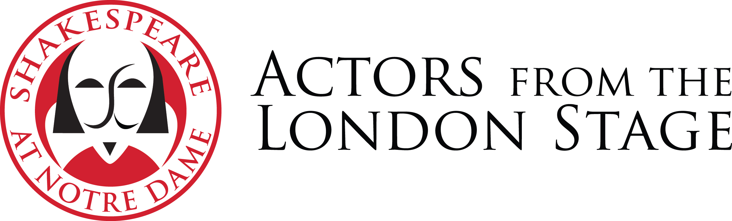
Actors From The London Stage
Class Visit Request Form
Please complete and email to aftls@nd.edu.

Institution:

Faculty member name:

Faculty member cell phone:

Faculty member email:

Course title and number:

Day (ex: Tuesday):

Date (ex: March 31):

Time:

Location:

Number of students:

Classroom capacity:

Text to be studied:

What would you like the actor(s) to do in your classroom?

Is there any other required or optional class work in connection with the residency?

How will the students be prepared for the class visit?

Special requests or notes:

Please complete and email to aftls@nd.edu.

