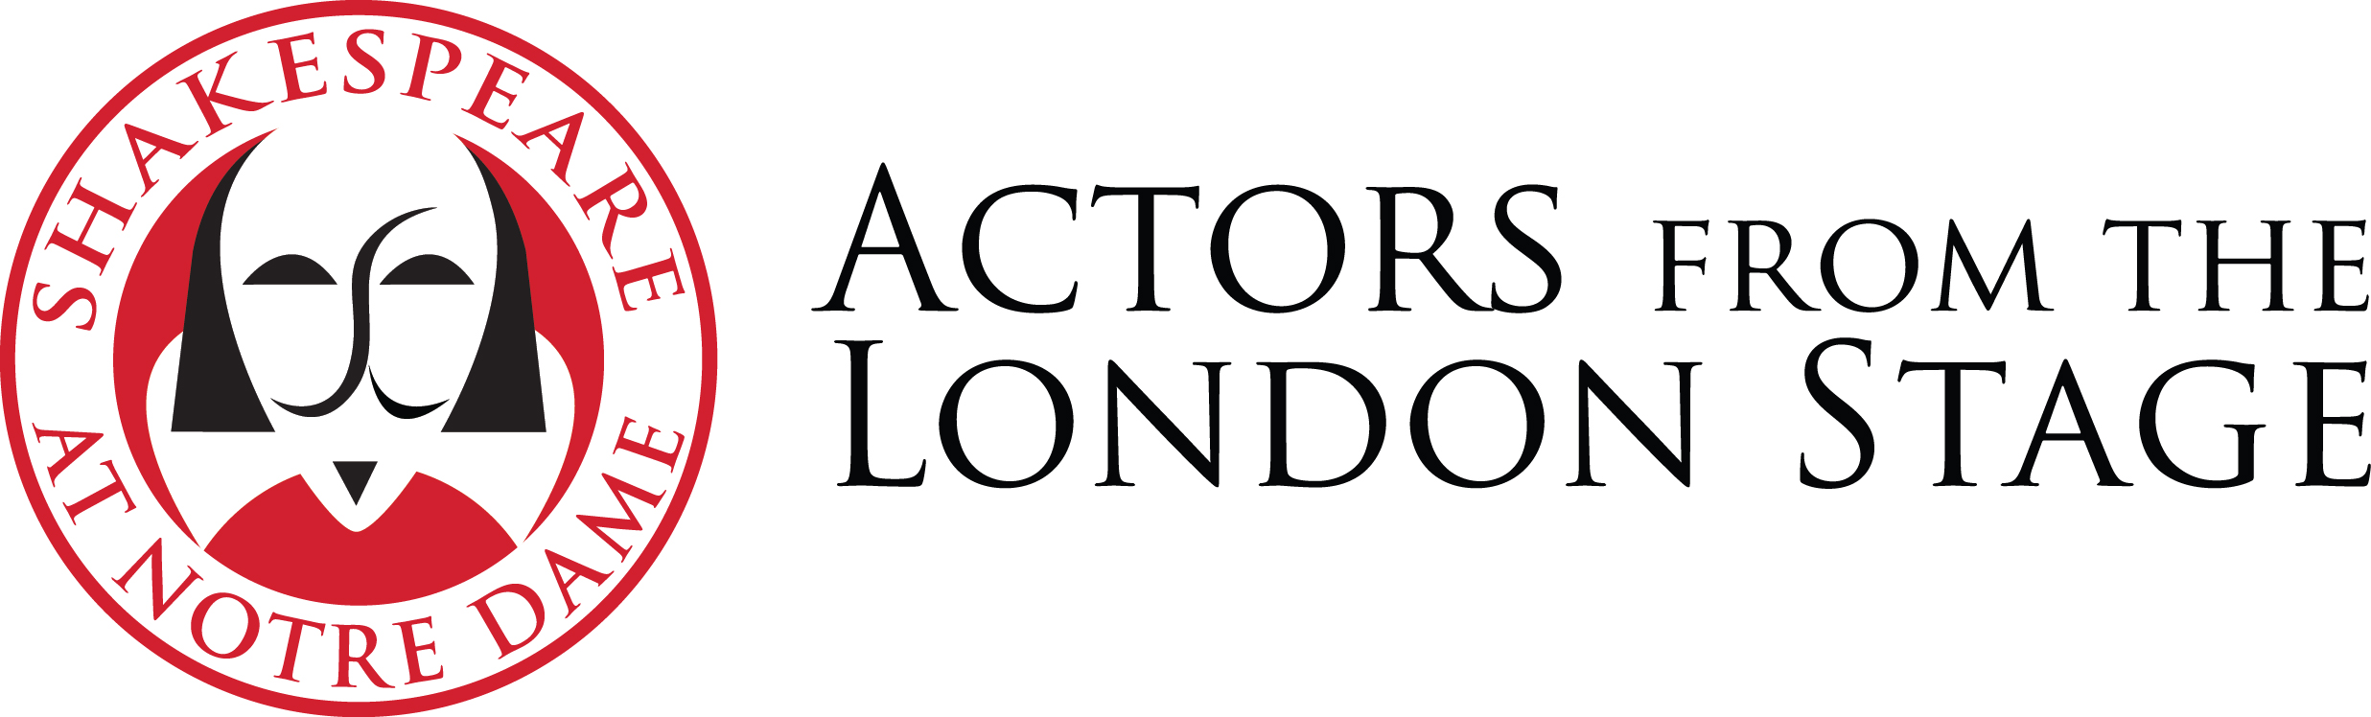
Actors From The London Stage
Fall 2018 Tour: Hamlet
Actor Bios
Updated 8.9.18

Grace Andrews (Bernardo/Ophelia/Laertes/Guildenstern/2nd Player/Sailor)

Grace trained at Guildhall School of Music and Drama, London. She has worked with progressive and international directors such as Declan Donnellan, Katie Mitchell, Vladimir Shcherban, Jane Gibson, Owen Horsley, Alain Perroux and Mike Alfreds, and undertook a three-week masterclass with Christian Burgess, Laurent De Montalembert and Julie Brochen at Primo Del Teatro in San Miniato, Tuscany. Professional acting experience includes The Forbidden Zone (Schaubühne production), Peer Gynt (Barbican and London Symphony Orchestra), See What I See (Oxford Playhouse, Eyestrings), Tomorrow I Was Always A Lion (Arcola, Belarus Free Theatre) and The Winter’s Tale (international tour, Cheek By Jowl). She holds a diploma in both classical and musical theatre singing, and works regularly in voiceover. She is involved in a two-year research project with the European drama school network Écoles des Écoles on “Acting and Entrepreneurship.” Grace teaches at Guildhall on their Preliminary Acting Course, their outreach programmes, co-runs the short course, “The Female Actor,” and is co-director of their Summer School. She runs workshops for Cheek By Jowl, and frequently teaches at Fontainebleau School of Acting, Paris.

Peter Bray (Polonius/1st Player/1st Gravedigger/Priest/Osric)

This is Peter's second tour with AFTLS, having previously toured last fall with Measure for Measure. Peter has performed on some of the most prestigious stages in the world, working with the Royal Shakespeare Company (The White Devil, Arden of Faversham, The Roaring Girl, The Heart of Robin Hood), as well as the National Theatre, Shakespeare’s Globe, the Folger Shakespeare Library, and the Royal Lyceum Theatre Edinburgh. His stage, film, and workshop experience allowed him to work with Bill Buckhurst, Pia Furtado, and Dan Barnard. He has taught extensively at the Royal Central School of Speech and Drama as well as at the Arts Educational Schools. Additional workshop highlights include: Oxford University, Boston University, and SHAPE military school.

Ben Eagle (Ghost/Francisco/Claudius/Reynaldo/2nd Gravedigger)

Ben trained at the Royal Central School of Speech & Drama, graduating with the Lilian Baylis Award for Excellence. Theatre: Alan Ayckbourn’s Neighbourhood Watch, Sleeping Beauty, Measure For Measure (AFTLS 2017 US tour), Falstaff in The Merry Wives of Windsor, Robin Hood, Much Ado About Nothing, This Was The World and I Was King (Arts Theatre West End), Robin Hood, The M Word, The Eighth Wonder of the World, Animal Farm, 1984, Much Ado About Nothing, Twelfth Night, Waiting For Godot, A Christmas Carol. Film: Alice The Wild, The First Film. Ben is a regular voiceover artist and singer and has performed in concerts at venues including the Royal Albert Hall. Ben has directed two plays: Doubt: A Parable by John Patrick Shanley and The Audition by James Johnson. He has also, more recently, been Assistant Director on Company, A Little Night Music, Sunday in the Park with George and Merrily We Roll Along at the Royal Central School of Speech & Drama. Ben often works one-to-one with drama school auditionees and is a mentor for students at Central. He is regularly asked to host corporate events and has experience as a film festival producer. He is delighted to be returning to the ranks of AFTLS.

Madeleine Hyland (Marcellus/Hamlet/Fortinbras)

Madeleine spent her childhood in Newcastle-Upon-Tyne and Manchester, UK, before heading to New Zealand for secondary school. She won the Sam Wanamaker Award for Most Promising Actor in the national SGCNZ Sheilah Winn Shakespeare Festival and studied at the Globe Theatre with the SGCNZ Youth Company. After earning her degree from Unitec School of Performing and Screen Arts, Auckland, she formed her own theatre company, Peripeteia. With Peripeteia she produced and acted in Cymbeline, The Tempest, Pinocchio, Three Sisters and Much Ado About Nothing. She joined the Education team at the Globe, directing groups in the Our Theatre productions of A Midsummer Night’s Dream and The Tempest. She assistant-directed Tim Carroll (currently the Artistic Director of the Shaw Festival) over several years on productions with students from Rutgers University. She has tutored and directed at a variety of institutions, Central School of Speech & Drama, the UK, NY and Dutch Factory, Verbier Classical Music Festival in Switzerland, and at Samling Academy in Durham, UK. She is also an artistic consultant to Angus Vail on the Container Globe, which will first be built in Detroit. Madeleine has directed A Midsummer Night’s Dream in 2010, Troilus and Cressida in 2012, and Measure for Measure in 2015. She has performed in 20 of Shakespeare’s plays in half a dozen countries, and has been a core member of The Factory since 2008, playing regularly in Tim Carroll’s productions of Hamlet, The Seagull and The Odyssey. As well as a passion for Shakespeare, she has a great love of new writing, having recently been involved with workshops at the RSC of Will Eno’s Middletown, Matt Hartley’s Eyam, and with Historic Royal Palaces, Six Wives & Reg by Patrick Barlow. She plays Lady Crawley in the upcoming ITV/Amazon television adaptation of Thackeray’s Vanity Fair.

Wendy Morgan (Horatio/Gertrude/Rosencrantz)

Wendy has a 43-year international career on stage, screen, television and radio. Her second job was the John Schlesinger film Yanks with Richard Gere, for which she won the Evening Standard’s Most Promising Newcomer Award. Her passion for Shakespeare began when she joined the Peter Hall Company at the National Theatre. She performed there for many years, in shows including Coriolanus with Sir Ian McKellen, Yonadab with Sir Patrick Stewart, and Martine, for which she was nominated for the Olivier Awards and Evening Standards Best Actress Award. She also joined Sir Peter’s company at Bath Theatre Royal for Henry IV Parts 1 and 2. Other Shakespeare productions include Desdemona in Othello and Celia in As You Like It for The Ludlow Festival, and Dogberry in Much Ado about Nothing for The Wyrd Sisters. Onscreen, she has been seen as Bianca in Othello for Sir Jonathan Miller, and as The Nurse in the film Romeo and Juliet Are Dead. Currently, she can be seen in the the film Edie on general release, and in the soon-to-be released Mrs. Lowry and Son with Vanessa Redgrave. She toured to the Shakespeare Theatre in Washington in 2009 with Helen Mirren in Phedre, and is very excited to be back in the USA.

