

**Spring 2017 Actor Bios**

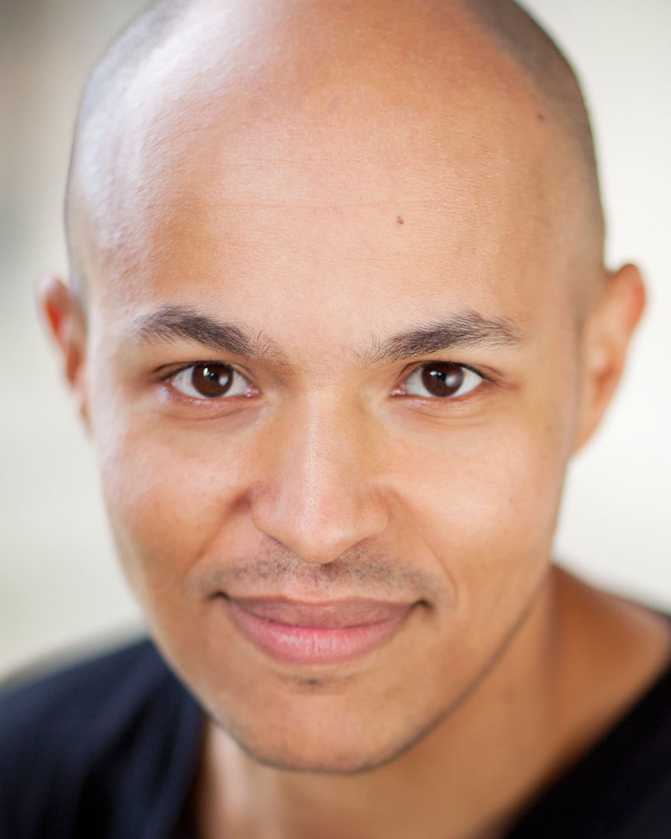**WILLIAM DONALDSON** (Friar Lawrence/Lady Capulet/Tybalt/Peter/Montague)trained at LAMDA. As a theatre practitioner and director he has worked with The Royal National Theatre, The Young Shakespeare Company, The Shakespeare Schools Festival, and The Arcola Theatre, among others. He is an artistic associate of Tucked In Productions (specialists in theatre and puppetry) and Beautiful Creatures Theatre Co. (a site specific theatre company). Career credits include: Prospero in *The Tempest (*Young Shakespeare Company), Mercutio in *Romeo & Juliet* (Young Shakespeare Company), Trofimov in *The Cherry Orchard* (Brockley Jack), The Wicked Queen in *Snow White* (Old Vic), *The Experiment* by Mark Ravenhill (Soho Theatre), Valentin in *The Last of the Lake* (Newbury Corn Exchange / Brighton Dome co-commission). Film credits include *Captain Webb* (Marathon Films). William will be starring in new comedy web-series *Tie Me Down* in early 2017.

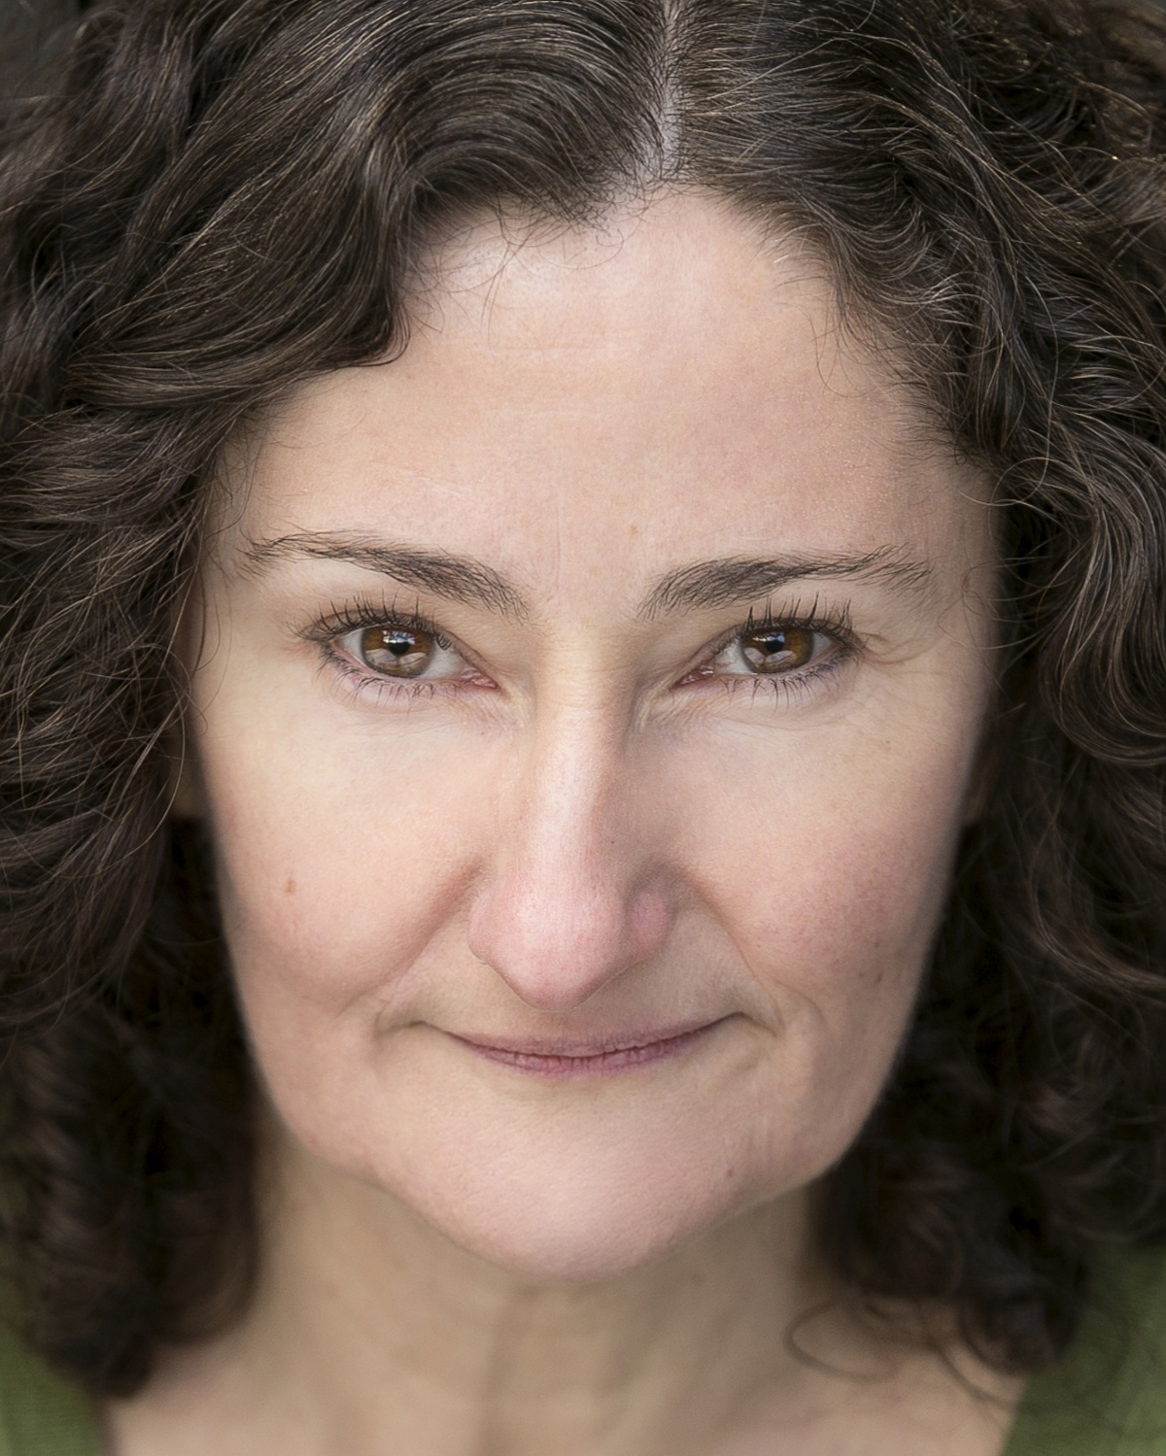**SARAH FINIGAN** (Nurse/Prince/Paris/Friar John/Old Capulet/Sampson) trained as an actor at Drama Studio, London and as a teacher at Goldsmiths University, London. She has taught Shakespeare and Drama in London high schools, run performing arts weeks in schools and delivered drama workshops to adults with disabilities. As an actor, her previous Shakespeare experience includes many roles for Changeling, an open air theatre company touring London and the South of England: *Twelfth Night, Macbeth, The Taming of the Shrew, The Merry Wives of Windsor and All’s Well That Ends Well.* Other Theatreincludes: *Deny, Deny, Deny* (Park Theatre, London), *The BFG* (Bolton Octagon), *The Hunters Grimm* (Watermill Theatre), *Cabbage Heart*  (Lyric Hammersmith, London), *The Last Women* (Belgrade Theatre), *The Portable Virgin* (Bridewell Theatre London and Segal Theater New York), *Fahrenheit 451, Death of a Salesman, One Flew Over the Cuckoo’s Nest* (TNT theatre), *Stepping Out* (Artsdepot London). Film includes: *Suffragette,* *Cesar Chavez,* *28 Weeks Later*, and *Cass*. Televisionincludes: *Marvellous,* *Call The Midwife, Count Arthur Strong, Cuckoo, Holby City, Doctors, Upstart Crow* (BBC), *Edge of Heaven, The Great Fire*, *The Bletchley Circle* (ITV), *The Borgias* (Sky), *New Worlds*, *Thinspiration* (Channel 4). Radio includes *Publish and be Damn’d* (BBC Radio 4).

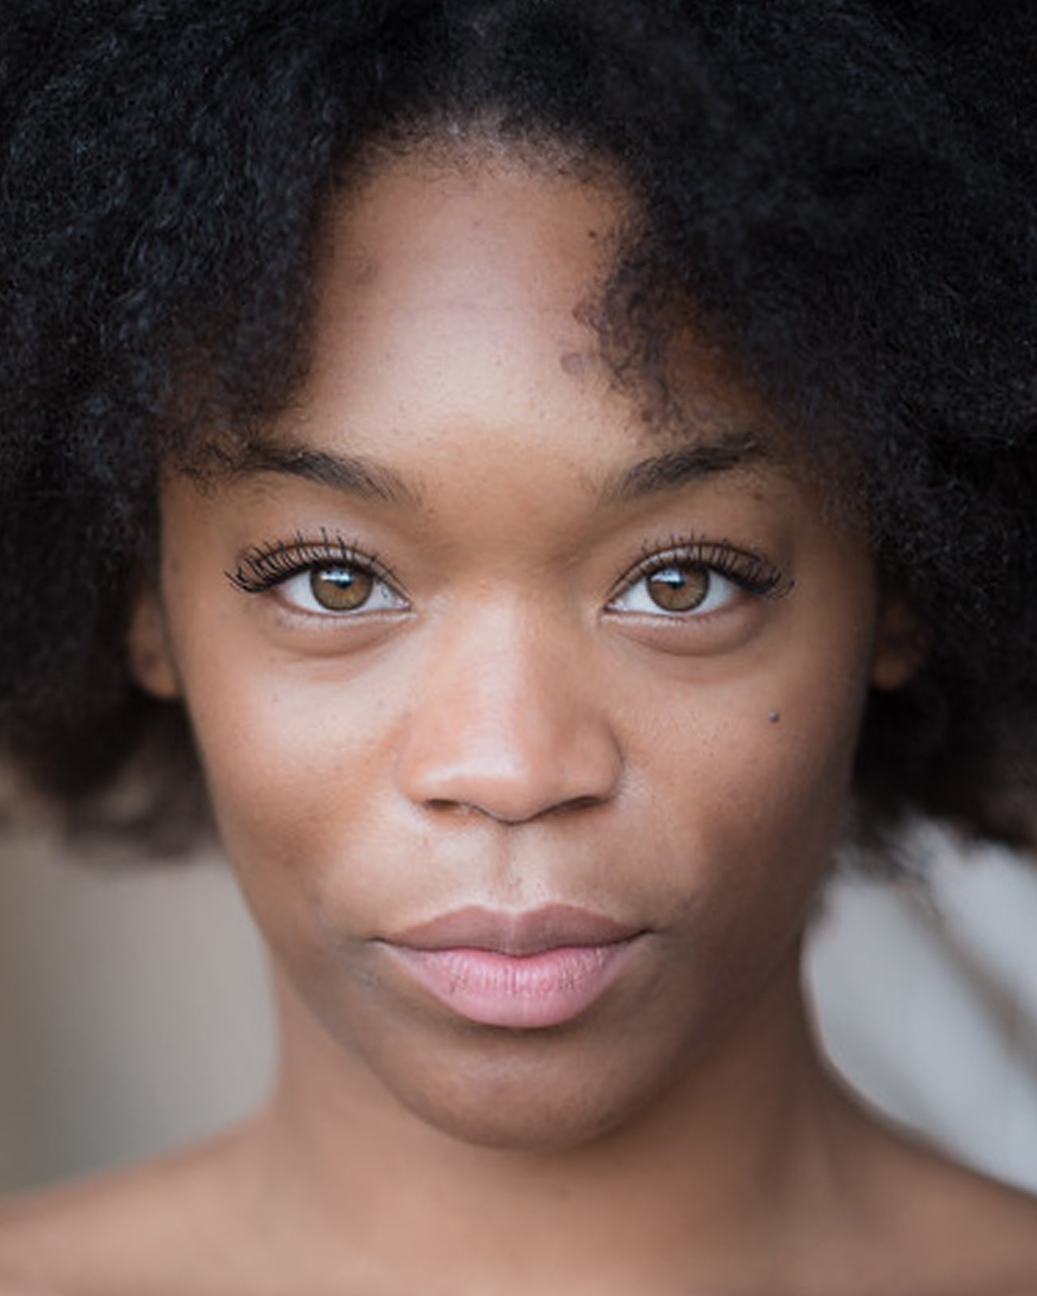**JASMEEN JAMES** (Juliet/Benvolio/Apothecary) graduated from The Court Theatre Training Company in 2015 where she did a two-year intensive in Acting. Credits include *Othello* (Iago), *A Midsummer Night's Dream* (Puck), and *Women of Troy* (Andromache). Jasmeen has also just finished working at The Orange Tree Theatre in the primary Shakespeare season where she played Antipholus of Syracuse in *The Comedy of Errors*. The project involved school workshops to help students understand the plot and unlock the text.

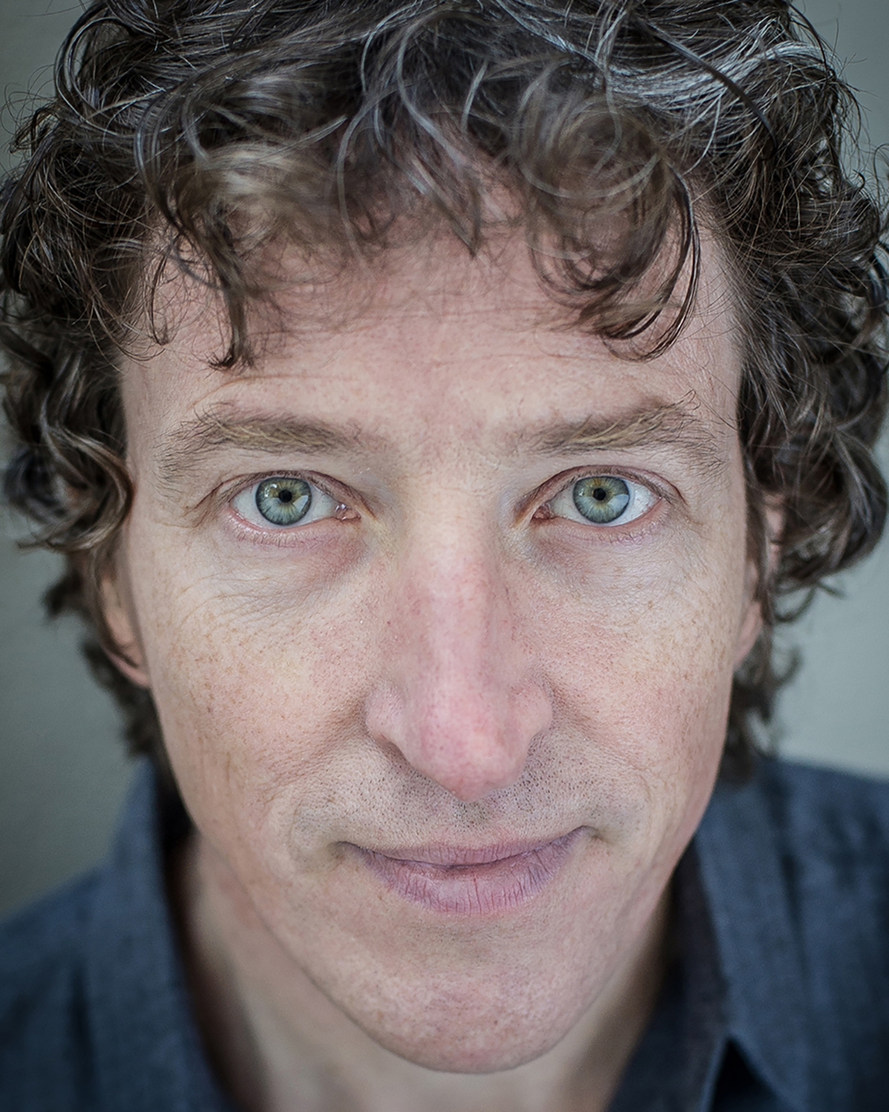**ROGER MAY** (Mercutio/Capulet/Balthasar/Abraham) has been a professional actor for 25 years. His theatre credits include: William Shakespeare in *For All Time* (Rye Festival, national tour planned for 2017); Desmond in *The Winslow Boy* (Rose Theatre, Kingston and national tour); The Father in *The Railway Children* (Waterloo Station); Monsignor Magee in *The Last Confession* (Chichester and Theatre Royal Haymarket); Margarelon in *Troilus and Cressida* (Edinburgh International Festival and RSC Stratford-upon-Avon); Elyot in *Private Lives* (Basingstoke); Hamlet in *Hamlet* (Wimbledon); Sir Andrew Aguecheek in *Twelfth Night*, Verges/Friar in *Much Ado about Nothing* (Nuffield Theatre, Southampton); Catesby in *Richard III,* Decius Brutus in *Julius Caesar* (Royal Shakespeare Company); Albie in *The Jail Diary of Albie Sachs* (Canadian Tour); Bertram in *All’s Well That Ends Well* (Actors From The London Stage). Television includes: *Hornblower, Mosley, Jeremiah, The Cazalet Chronicles, Peak Practice, The Hour, Father Brown.* Films: *The Scarlet Tunic, The Titchborne Claimant,* and *An Ideal Husband.* Roger has recorded over 100 plays for radio, as well as numerous audiobooks. As well as acting and teaching on a previous AFTLS tour, Roger has directed a number of plays including, in 2015, a five-person production of *A Midsummer Night’s Dream* at the University of Wyoming – during which he also gave classes and workshops.

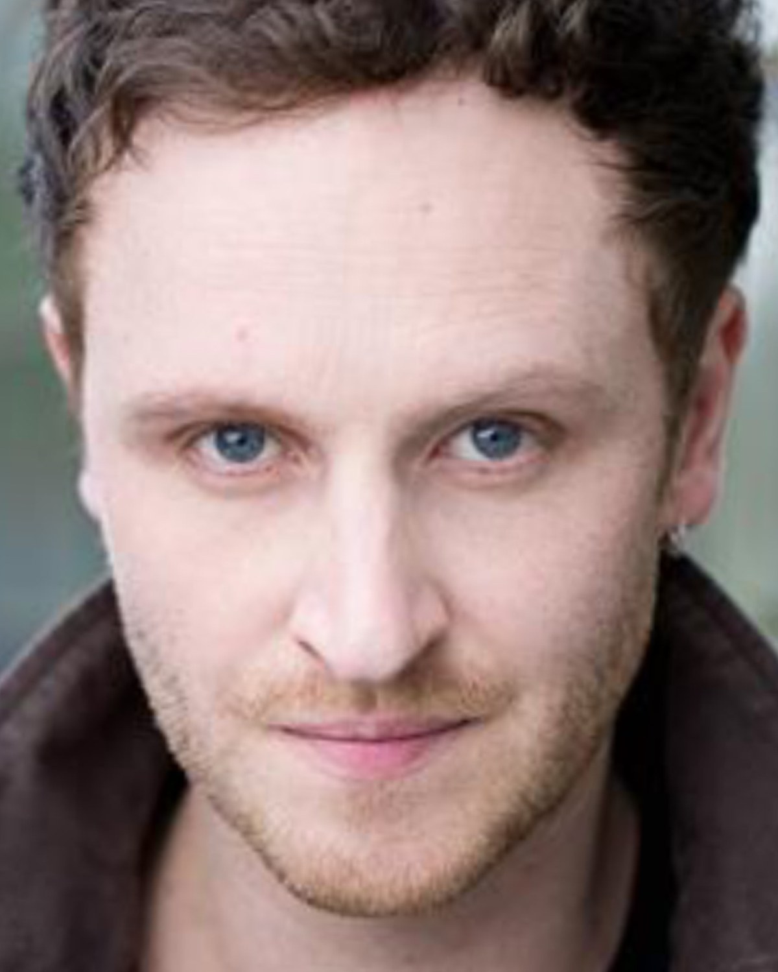**JACK WHITAM** (Romeo/Lady Montague/Gregory) graduated from the Bristol Old Vic Theatre School. Jack has performed in theatre, television, radio and film. Highlights include: *Macbeth, King Lear, Richard III,* and *Anthony and Cleopatra* (Royal Shakespeare Company); *Emperor and Galilean* (National Theatre); *Hamlet* (Shakespeare’s Globe); *The Wind in the Willows* (West Yorkshire Playhouse); *Citizen Kahn* (BBC); *Powder* (Red Films); and *Man Up* (BigTalk). He has led workshops in Shakespeare at leading drama schools in the UK and has recently adapted the epic Norse saga of Beowulf for the stage which is due to premier Summer 2017. This is his third production for AFTLS following *Much Ado About Nothing* in the fall of 2014, and *Othello* in the fall of 2013.